缓考申请流程说明

网址：<https://www.csu.edu.au/current-students/support-services/help-information/special-consideration>

1.

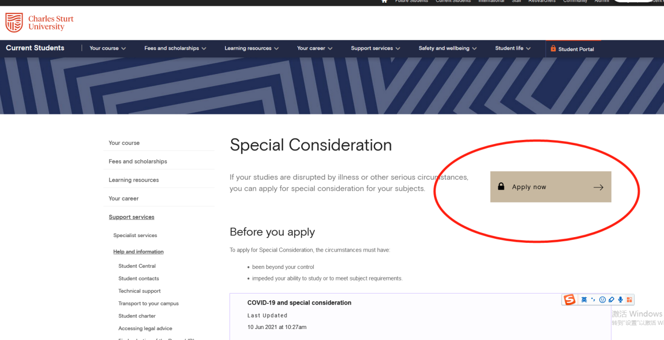

2.

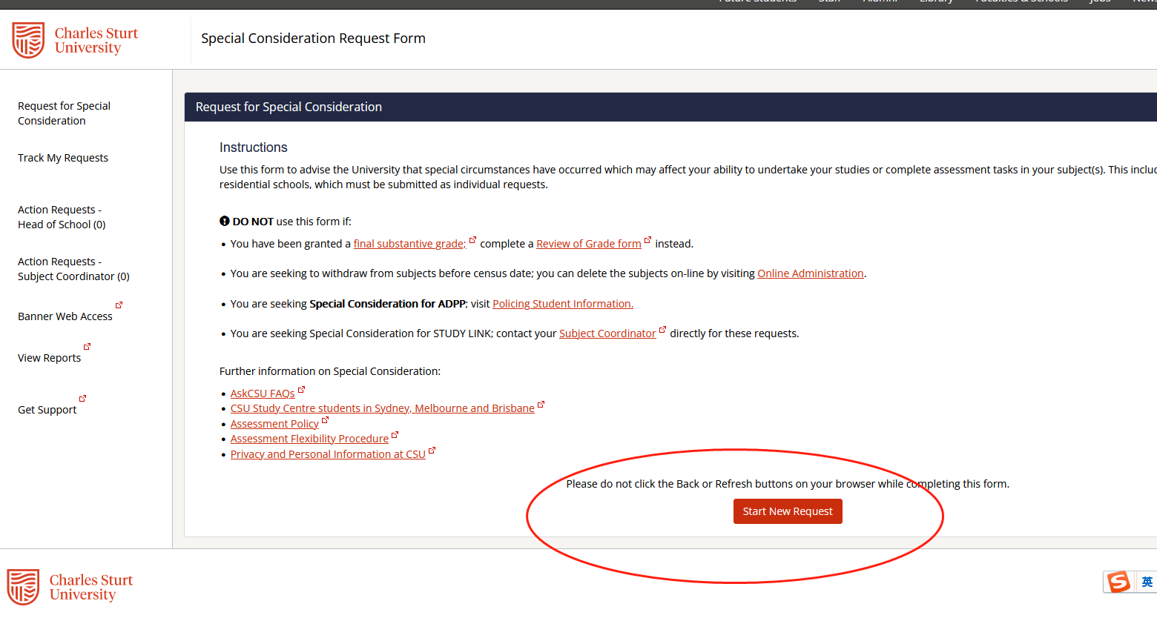

3.选择缓考科目和缓考原因，提交申请

